Changing RAM Starting Address

After opening the ble_app_uart_pca10040_s132 program in SEGGER Embedded Studio, go to View and click on Project Explorer. In Project Explorer, right click on the Project ‘ble_app_uart_pca10040_s132’ and click Options…

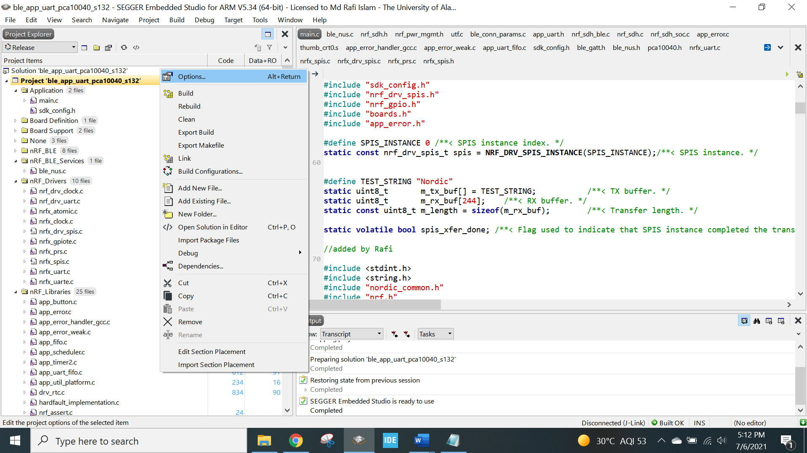

In the top left corner of the popup window (Options), change Release to Common from the dropdown menu.

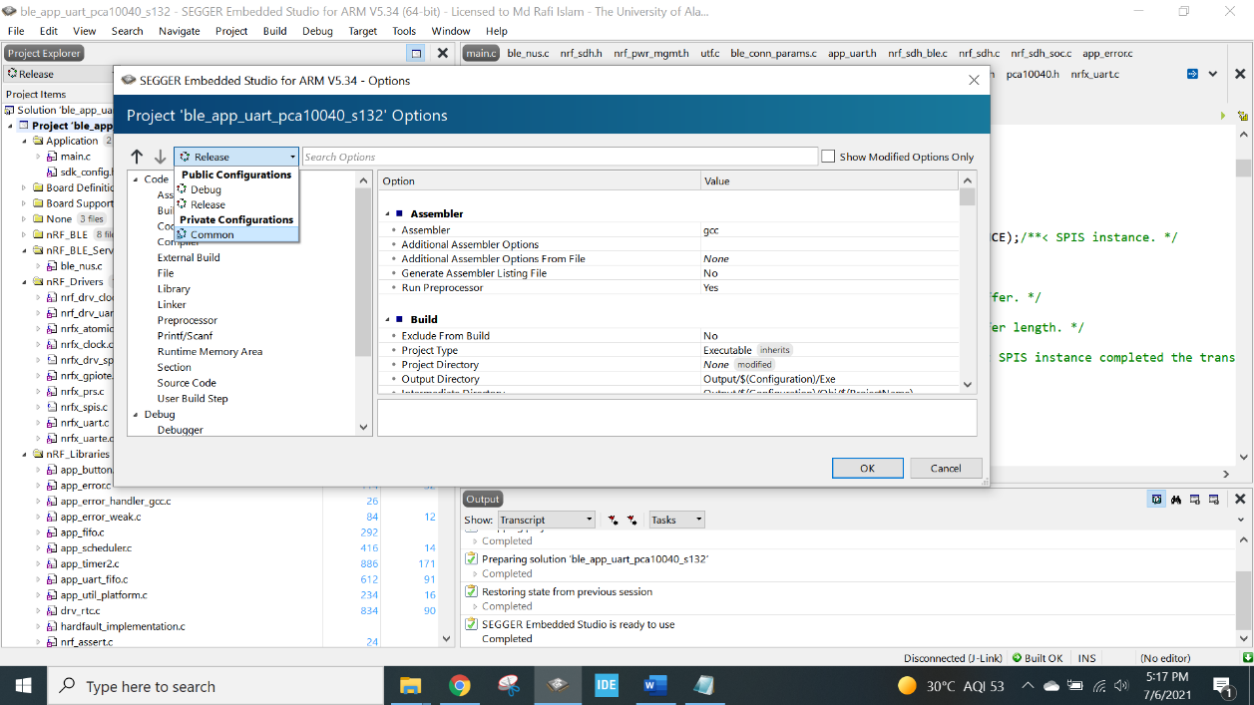

Now, go to Linker and double click on the Section Placement Macros and change the RAM_START to your necessity.



